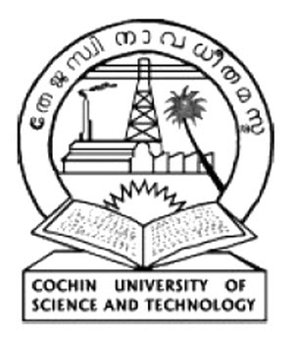 | COCHIN UNIVERSITY OF SCIENCE AND TECHNOLOGY
Application for Admission to M.Tech. Marine Biotechnology, 2021-2022 (Sponsored by Department of Biotechnology, Government of India)
Registration No: _________________________________ (Office use)
1 | Name of applicant
2 | Gender
3 | Age and Date of Birth
4 | Name of Mother
5 | Name of Father
6 | Nativity /State/Nationality
7 | Permanent Address
8 | Address for Communication
9 | Phone No. and E-mail
10 | Religion and Caste
11 | Communal Reservation
12 | Physically Challenged
13 | Whether belongs to Non-Creamy layer
14 | Qualification and marks
15 | GAT-B Score
Declaration

I, __________________________ , have read the notification and all other related instructions. All information and data furnished are true to the best of my knowledge and belief

Place:
 | Date:
 | Signature of Applicant
 | List of enclosures

